STOP THE ARMY’S PLAN TO DISCONTINUE ITS VOLUNTARY RELOCATION PROGRAM FOR PRESCRIBED BURNS!

Why should I be concerned?
The Army is planning another prescribed burn for 2006. The purpose of this burn is to clear vegetation from range MR-16. The last time the Army did a prescribed burn it resulted in a fire which escaped the Army’s control and consumed almost three times the 500 acres of vegetation it was intended to clear. At that time the Army had a program to temporarily relocate people who chose to stay away from their homes until the smoke cleared. This protected many people who could have been harmed by exposure to the particulate matter and hazardous materials contained in the smoke.

NOW THE ARMY IS PROPOSING TO END THIS VOLUNTARY RELOCATION PROGRAM.

The Army claims that this burn will be different. They say the burn area will be smaller. They say it won’t last as long because the area is smaller. They say there will be larger firebreaks to improve control of the burn. How can we trust the Army’s judgment? As far as we know they haven’t even analyzed why the fire escaped containment.
Why should we trust the Army this time? We should not TRUST the Army’s JUDGMENT BECAUSE THEY HAVE NoT DEMONSTRATED THAT THEY understand HOW to protect the RESIDENTS OF Monterey County.

WHAT CAN I DO ABOUT THE ARMY’S PROPOSAL

The first thing you can do is attend FOEJN’s Town Hall meeting on March 22, 2006. At this meeting we will discuss the

prescribed burns, why we believe they are a health hazard, and why we believe the
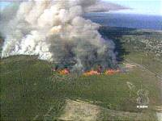
Army should continue to relocate residents who wish to temporarily leave the area until the smoke clears and it is safe for them to return to their homes. We will also encourage people to speak up, to submit comments to the Army and to the Department of Toxic Substances Control (DTSC) to let them know that we think it is wrong to discontinue the voluntary relocation program, that it is wrong to endanger the health of our residents. Town Hall meeting time and location are:

March 22, 2006
6:00 – 8:00 P.M
Oldemeyer Center
986 Hilby Ave.
Seaside, CA.

The second thing you can do is to make sure you submit comments to the Army to tell them that they MUST continue to relocate residents during the prescribed burns. Here are the points you should mention in your comments:
1) The Army must continue the voluntary relocation program for the well-being of Monterey County residents.
2) The Health Consultation report prepared by ATSDR is flawed and should be revised before it can be used to support the Army’s contention that a prescribed burn will not create long-term adverse health effects.
Send comments on the Army’s proposal to:
Gail Youngblood, BEC
U.S. Army Fort Ord BRAC Office
P.O. Box 5008
Monterey, CA 93944-5008
Comments must be received by
March 28, 2006
Send copy of your comments to FOEJN at above address

The Fort Ord Environmental Justice Network (FOEJN) was awarded a Technical Assistance Grant from the US Environmental Protection Agency in September 2003. The grant enabled FOEJN to hire a technical advisor to review and analyze the numerous technical reports generated by the cleanup effort. FOEJN hired Dr. Peter deFur in early 2004 and has worked with Dr. deFur on the priorities established in the grant. These priorities are:
- Groundwater contamination in several places
- The carbon tetrachloride in groundwater
- The landfill on Imjin Road
- Controlled and uncontrolled burns
- Small arms ranges and munitions removal
Since February 2004, FOEJN has met with Dr. deFur more than eight times, he has attended three FOEJN community forums and has presented comments at Army Community Involvement Workshops (CIW) held quarterly on the base.
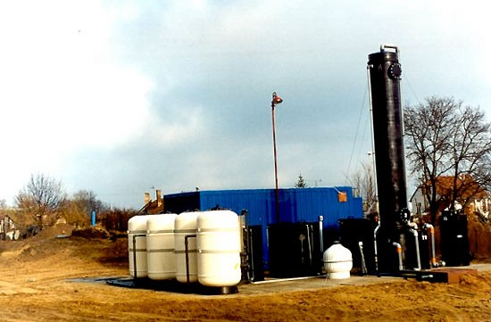
Groundwater Treatment System
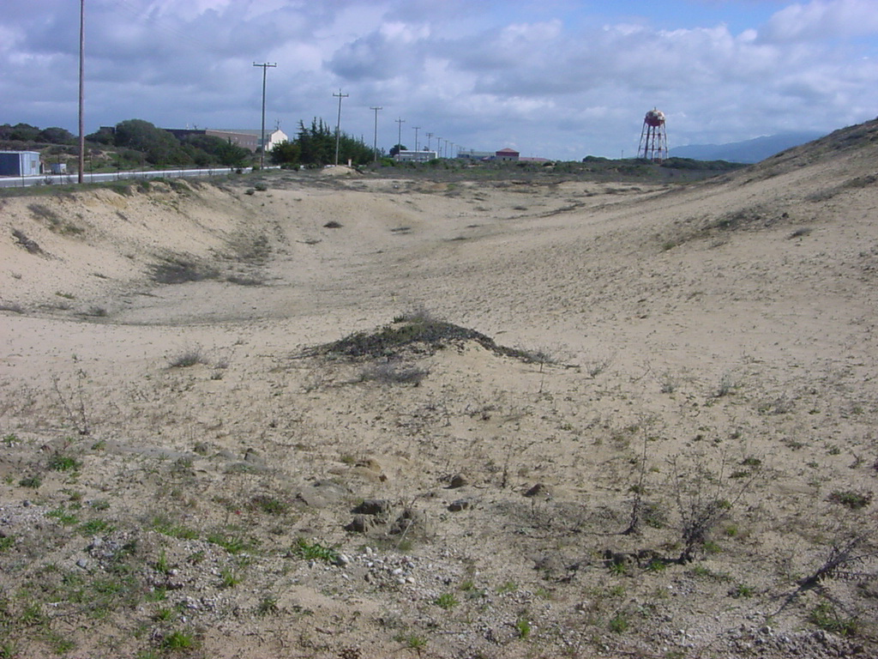Beach Ranges with Small Arms Debris

One of the major activities of any TAG advisor is reviewing the technical reports, sending the reviews to the citizens and preparing comments for the citizens to file with the Army or other regulatory agencies. FOEJN has filed comments on more than 50 documents since the TAG began more than two years ago. FOEJN staff and volunteers have worked with Dr. deFur and his staff to prepare materials for three community meetings on topics that include groundwater contamination, health effects of contaminated sites and problems with the burns on Fort Ord.
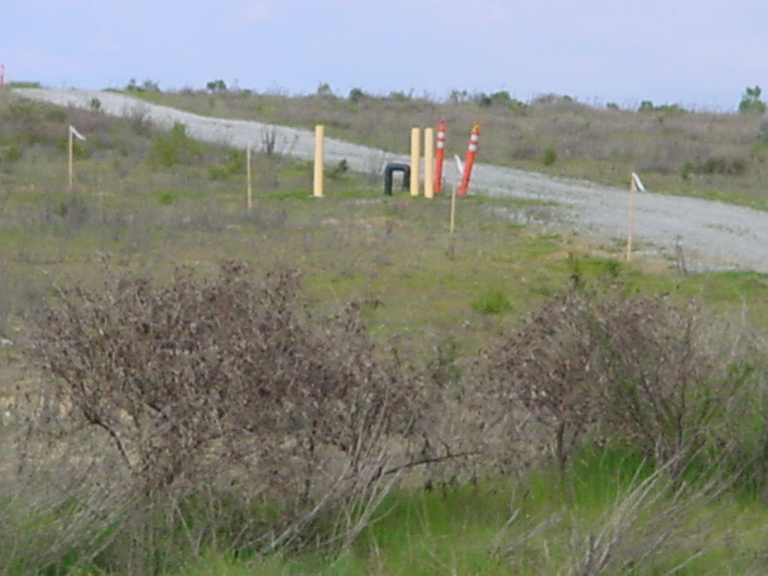
150 Acre landfill with monitoring wells beside a road over the landfill. This andfill s the source of groundwater contamination in one area.

